TASK 10:
class Solution {
public void reverseString(char[] s) {
int left = 0;
int right = s.length - 1;

while (left < right) {
char temp = s[left];
s[left] = s[right];
s[right] = temp;

left++;
right--;
}
}
}

Case 1:
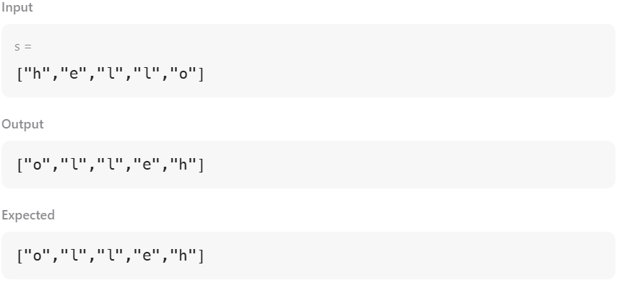

Case 2:
